**PROJECT DESIGN PHASE**

**–**

**II**

**SOLUTION REQUIREMENTS**

Date

17

2022

November

Project Id

PNT2022TMID19703

Project Name

AI

-

powered Nutrition Analyzer for Fitness Enthusiast

s

**Solution Requirements:**

**Functional requirement**

**:**

Following are the functional requirements of the proposed solution

.

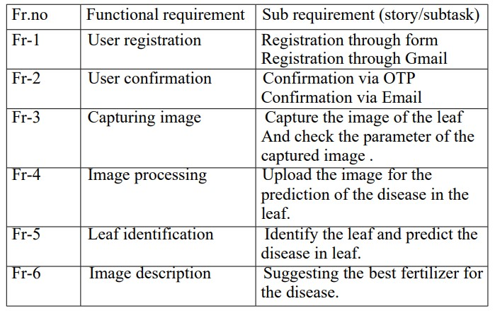

**Non**

**-**

**functional requirement:**

Following are the non

-

functional requirement of the proposed solution

.

